SIMPLE CIRCUIT WITH PULSE SENSOR AND COMMON ANODE RGB LED

What you will need:
- 2 x Breadboard

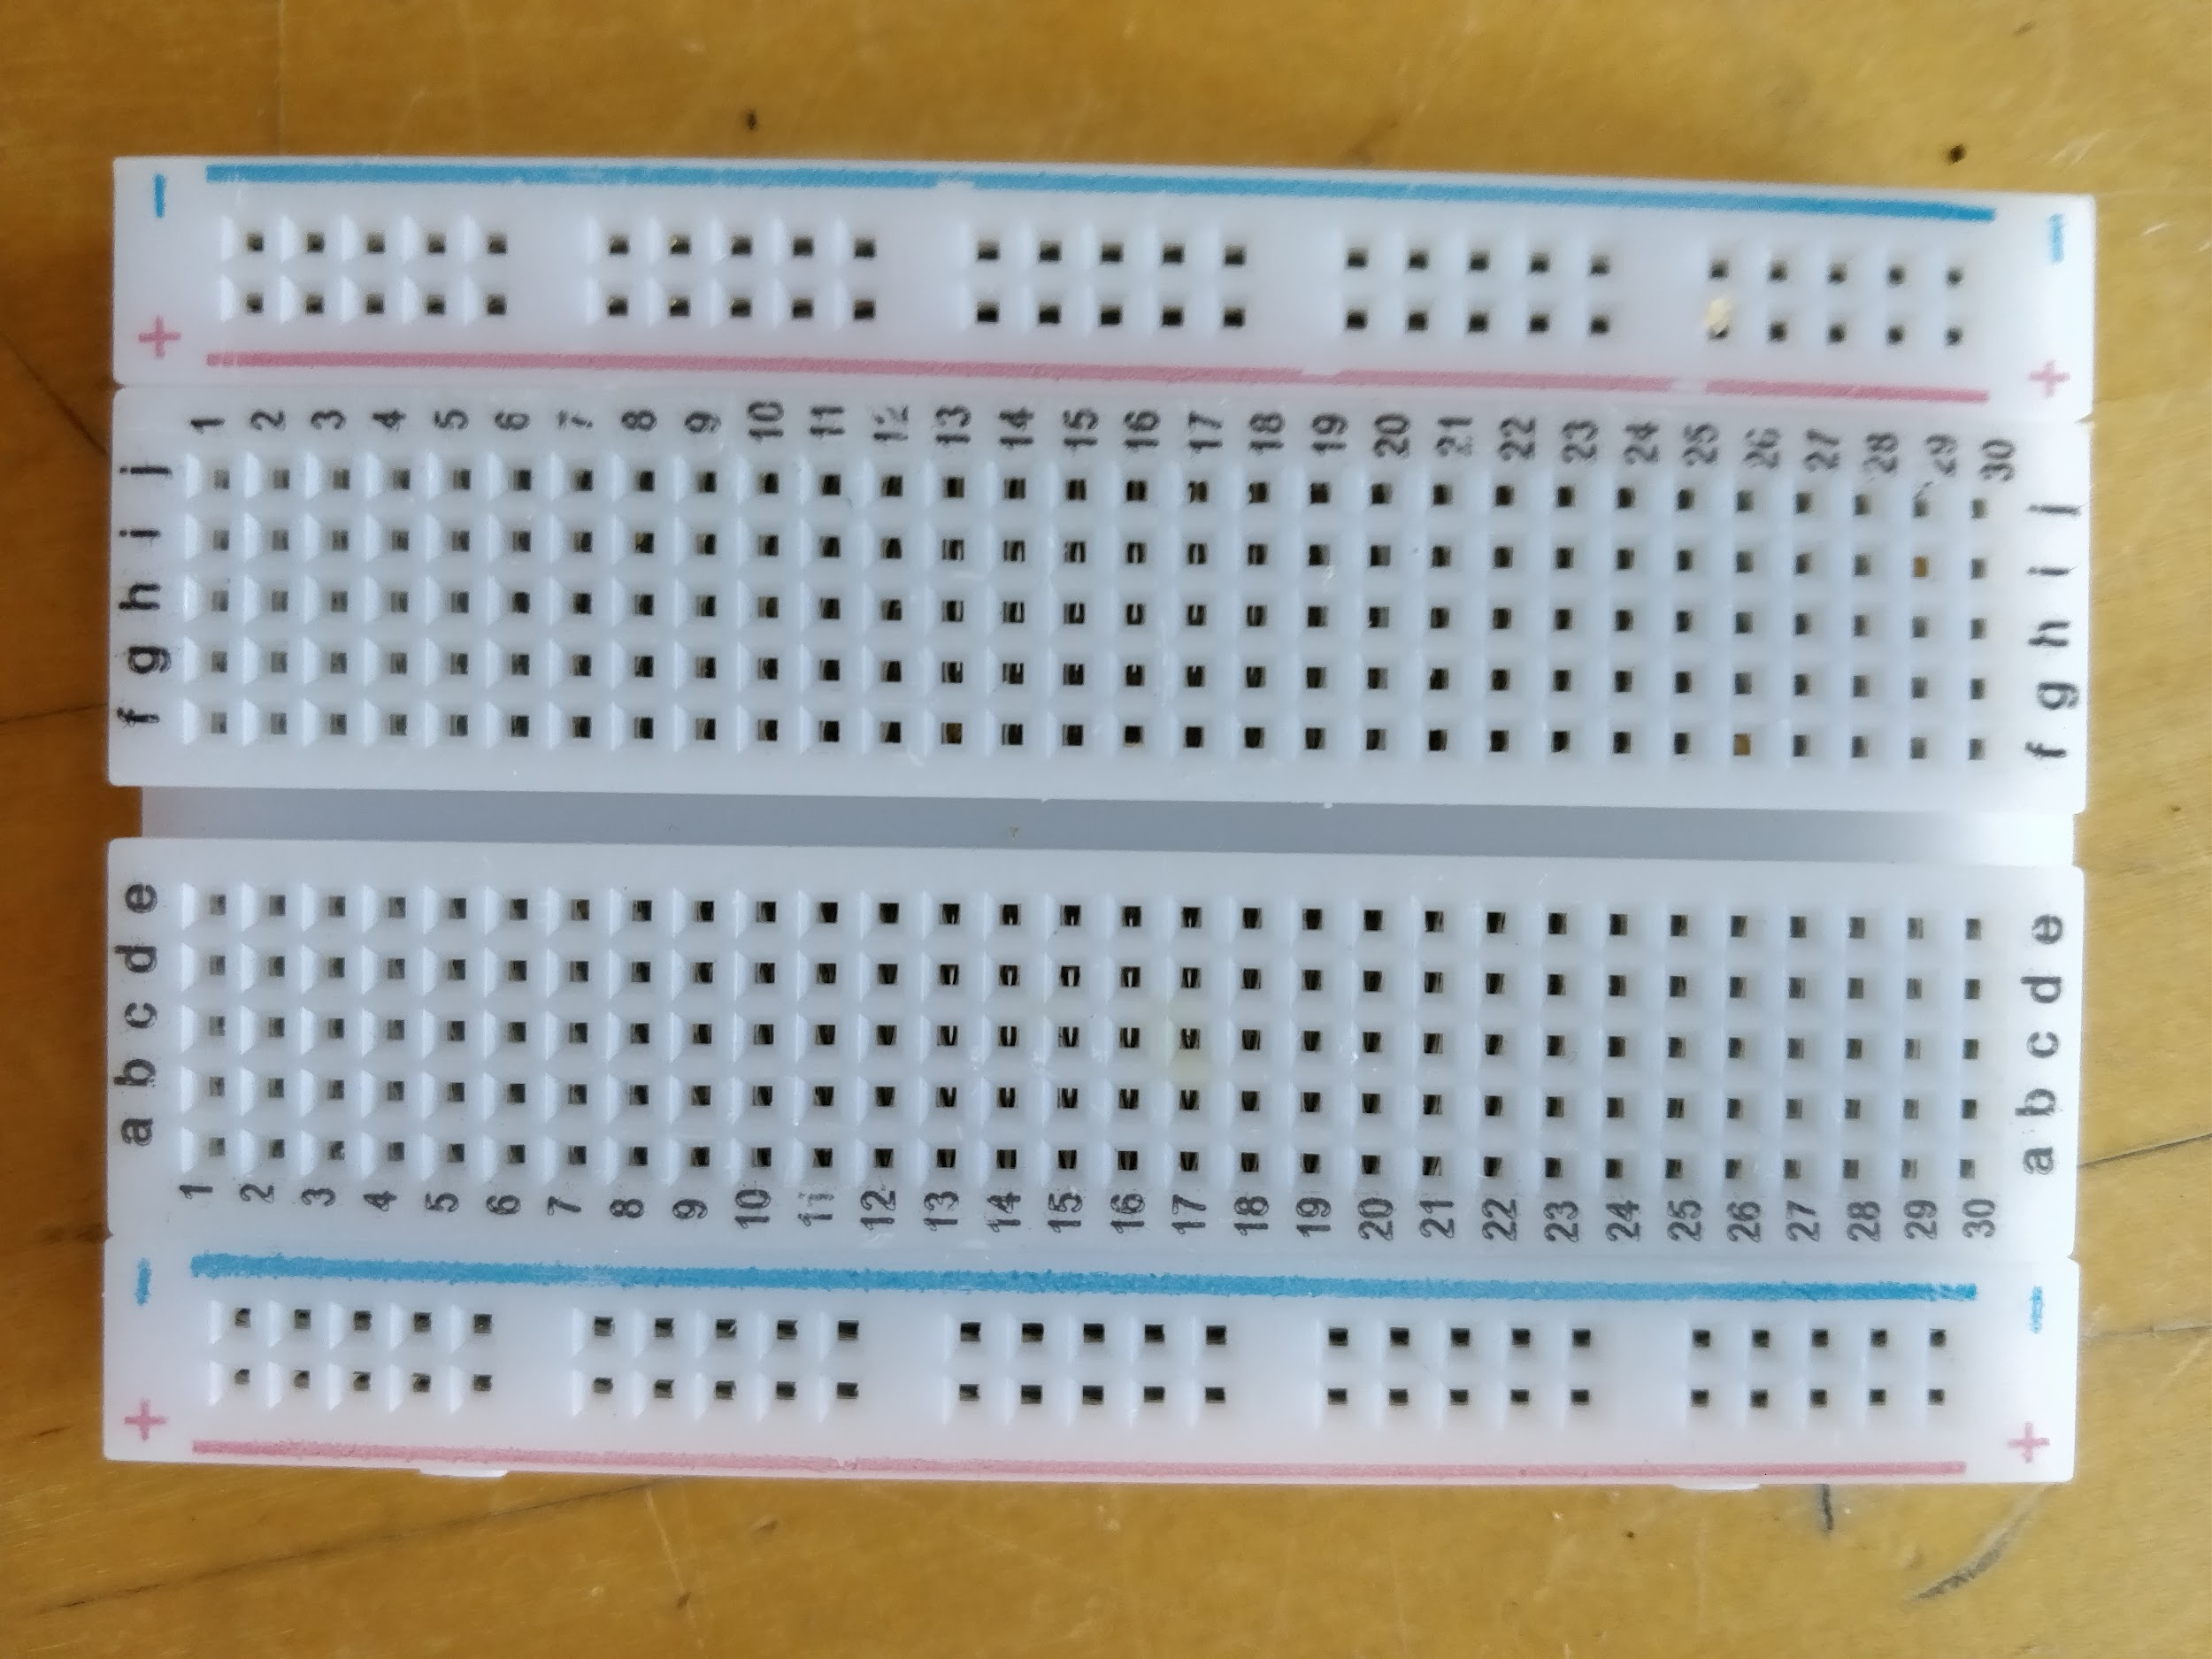
1 x Pulse Reader
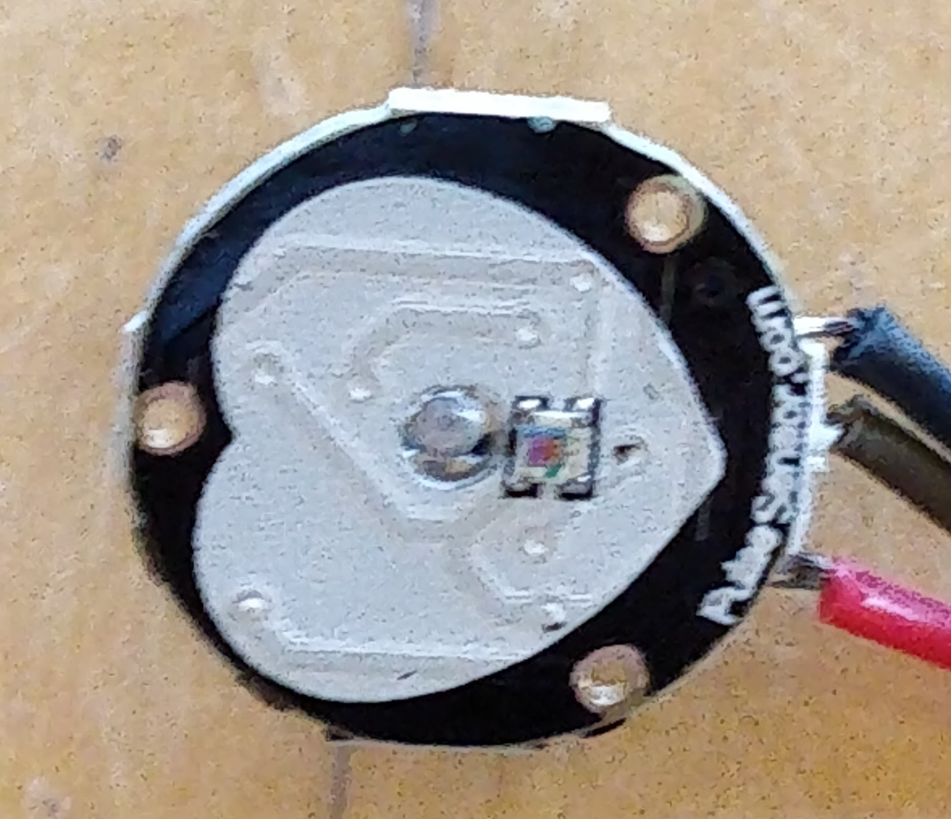
1 x ESP32
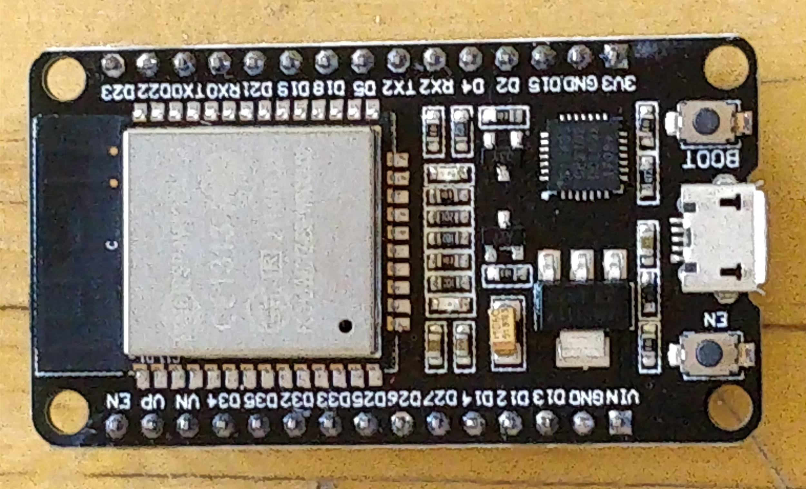
2x male-male jumper leads
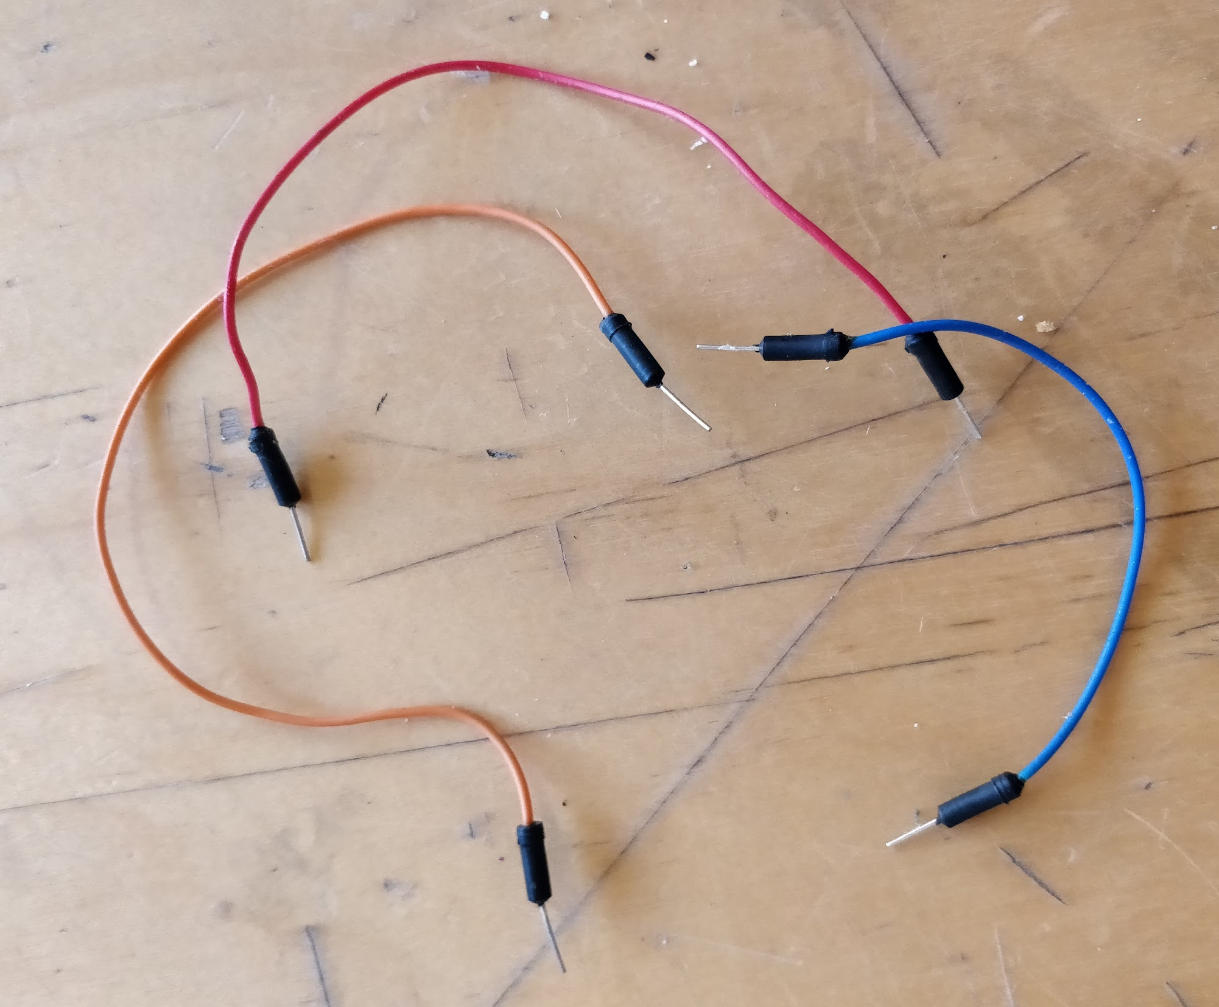

1 x Common Anode RGB LED
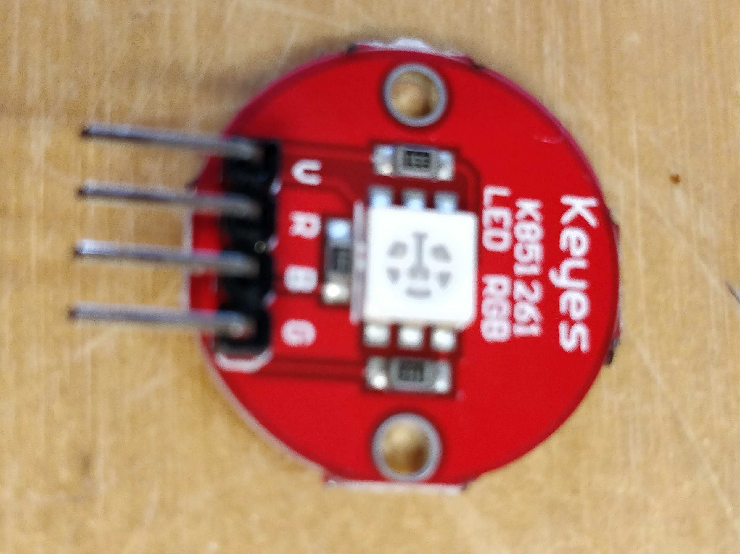
1 x Micro USB Cable
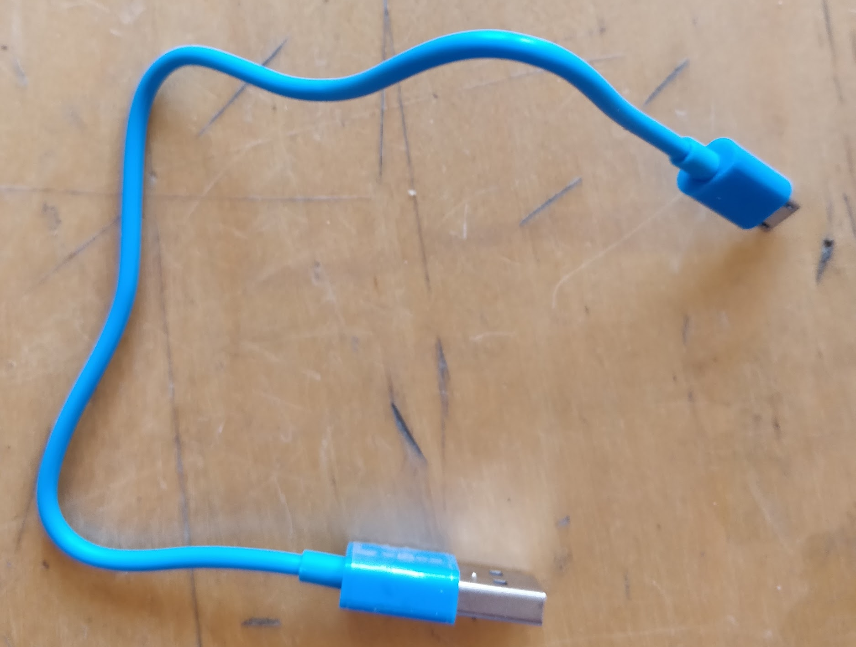

What to do:
1. Connect the 2 breadboards
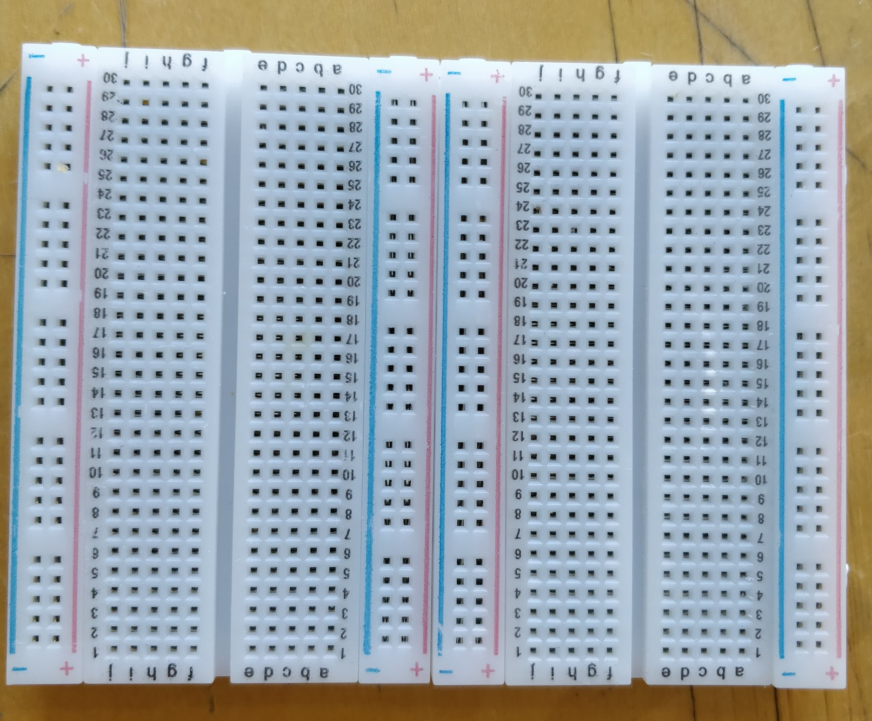

2. Push the ESP32 into place and connect the USB cable to it
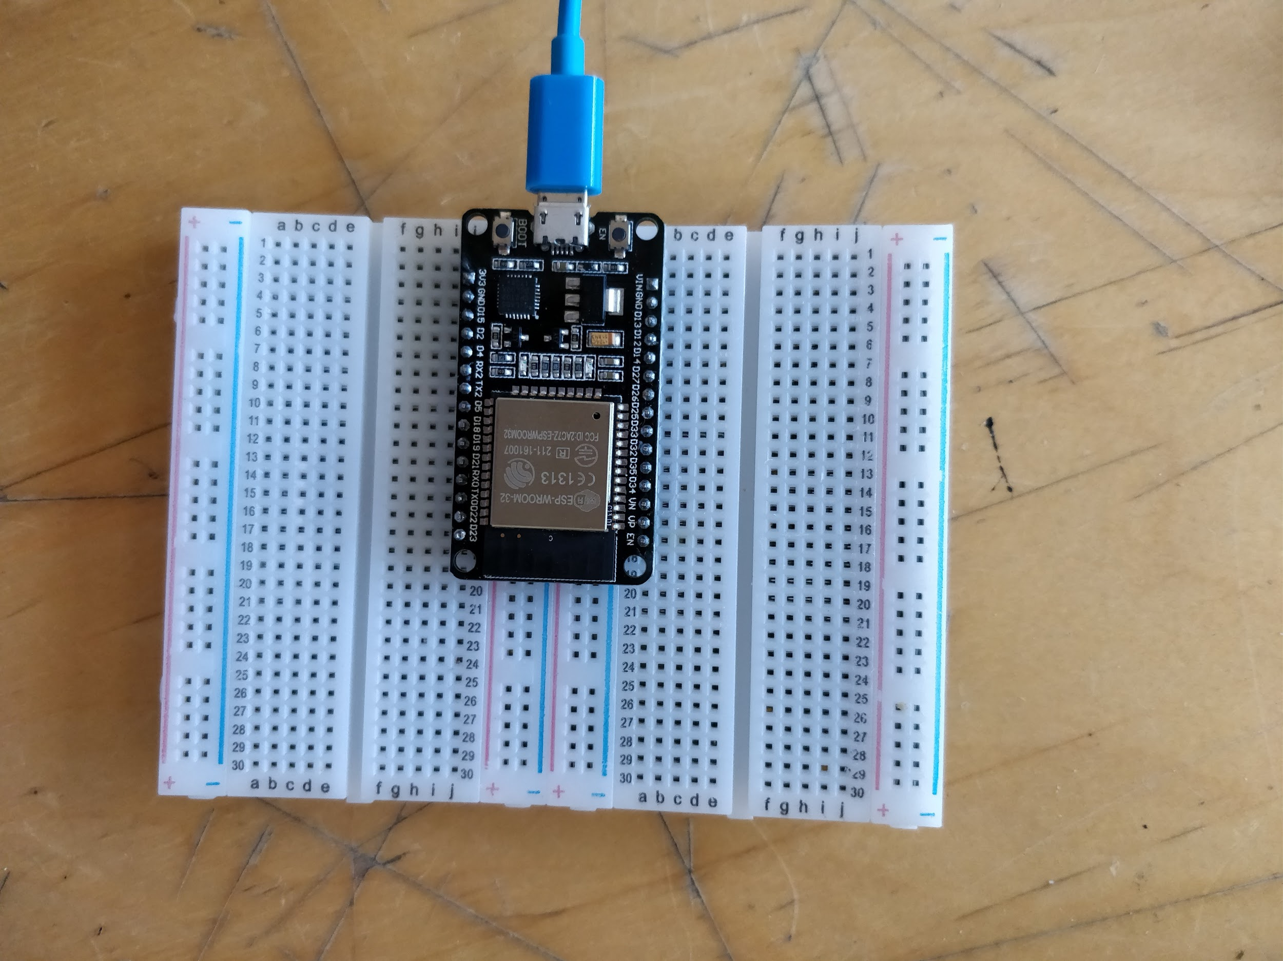

3. Connect the leads from the pulse sensor to the ESP32 using the breadboard as follows:
- From “-” on the pulse sensor to “GND” (ground) on the ESP32
- From “+” on the pulse sensor to “3V3” (3.3 volts) on the ESP32
- From “S” (signal) on the pulse sensor to D34 on the ESP32

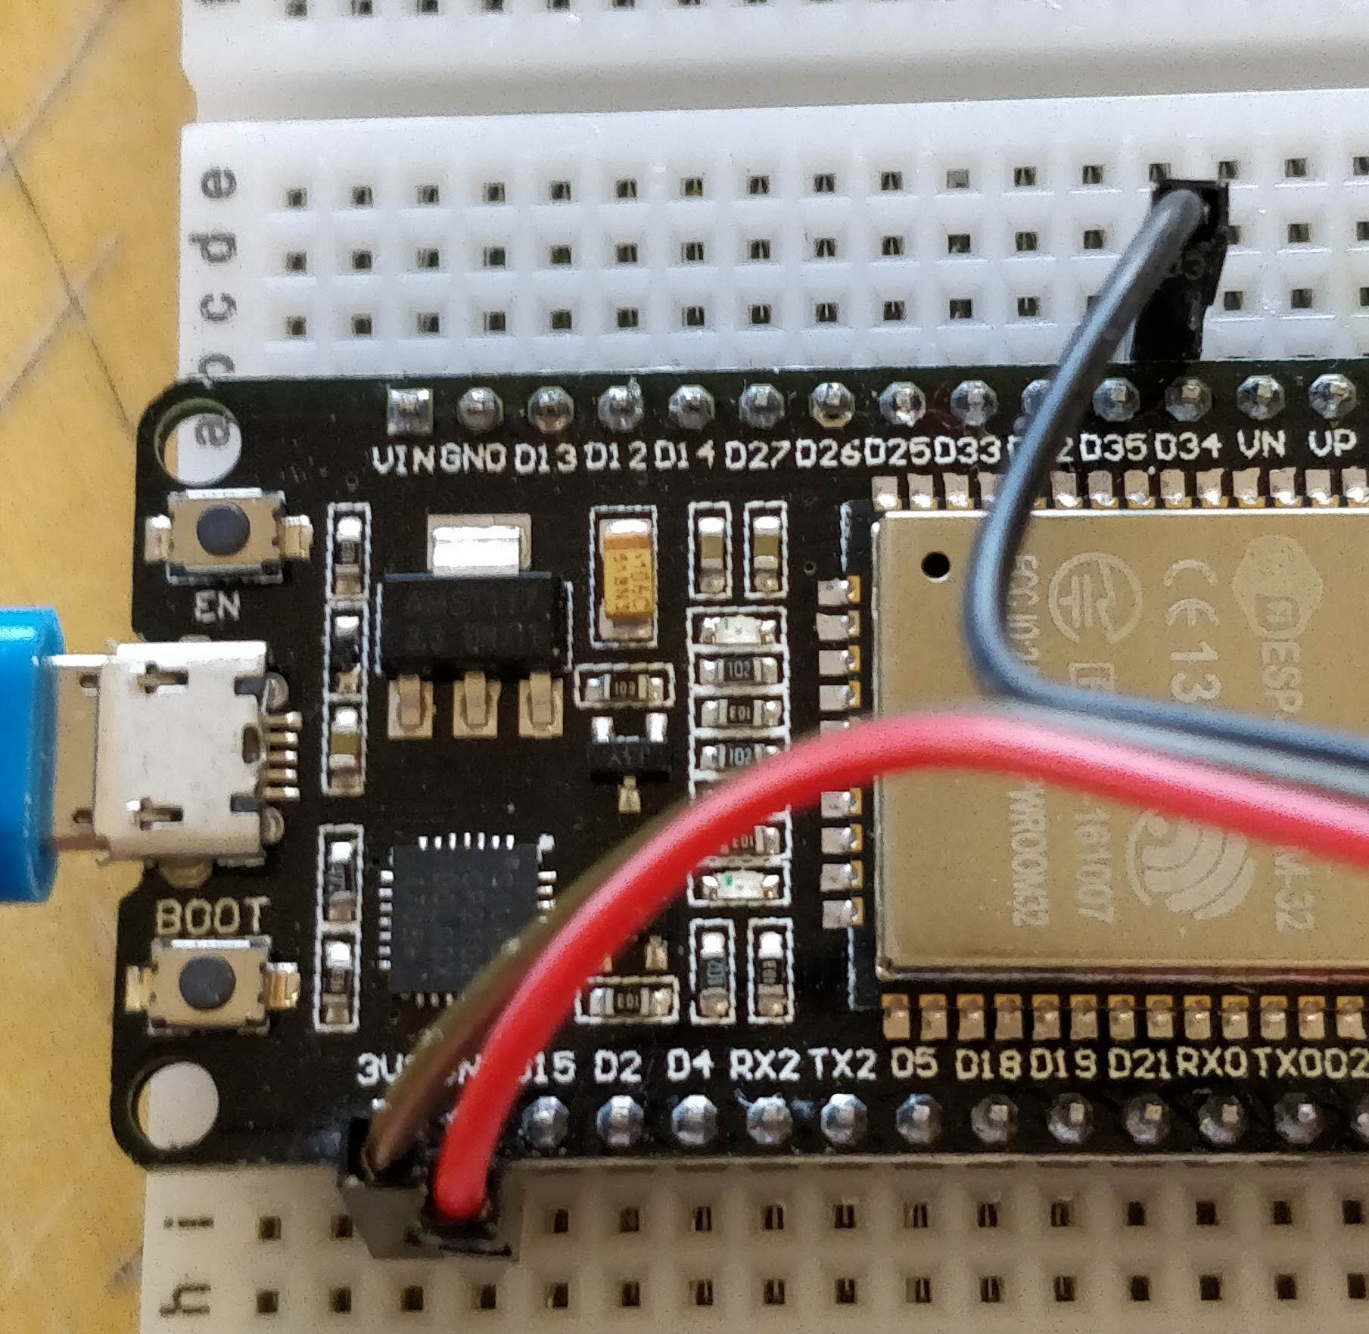

4. Connect the leads from the RGB LED to the ESP32 using the breadboard as follows:
- From “V” (volts) on the RGB LED to “VIN” (voltage in) on the ESP32
- From any of the other pins on the RGB LED to D5 on the ESP32
(“R” = Red, “G” = Green, “B” = Blue)
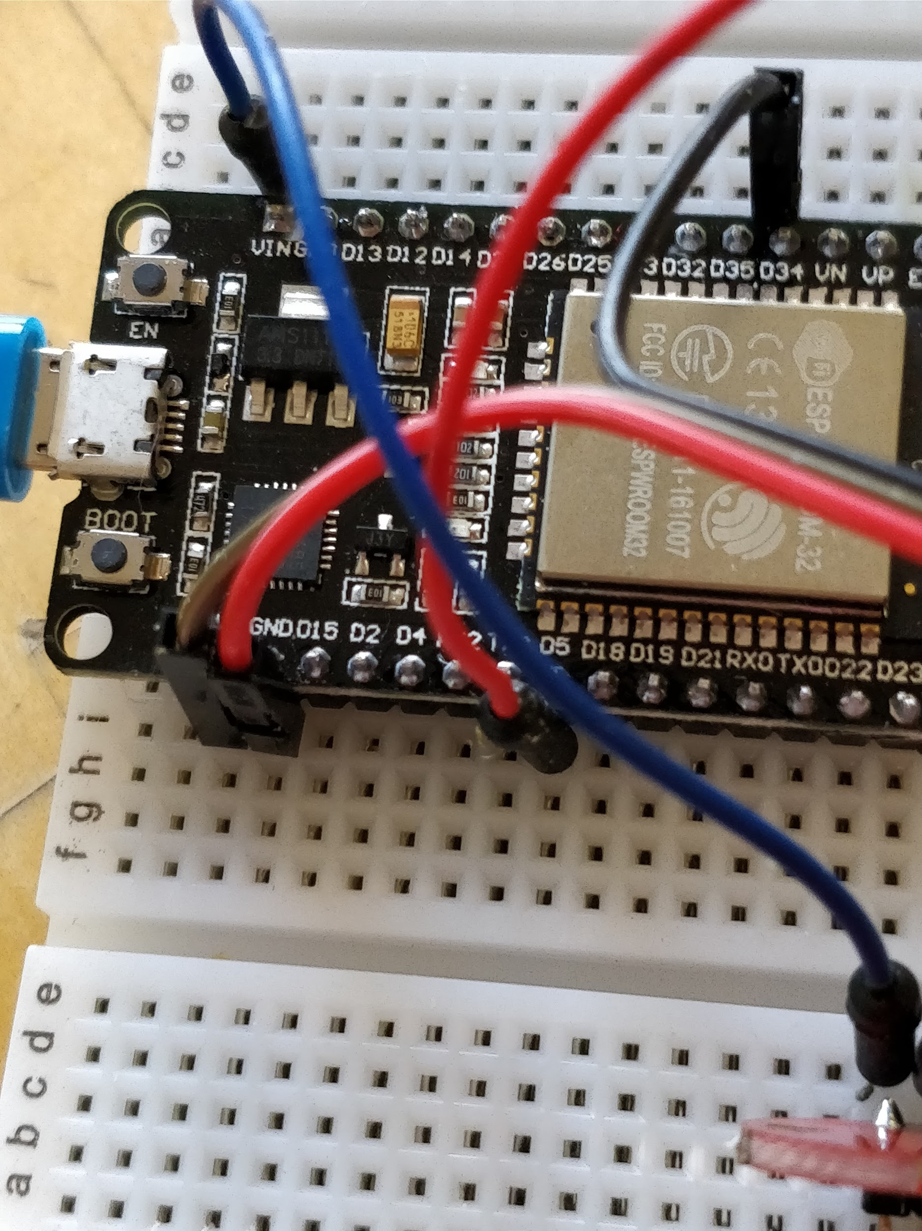

5. Plug the USB into the laptop. Hold the heart side of the pulse meter gently against your finger tip.

The RGB LED should flash on and off in time with your pulse, as a program has already been loaded onto the board. Try different areas such as the wrist or lip and see if you get a better or worse signal.

If you feel like it, you can look at the code we’ve been using today here:

https:/github.com/goatchurchprime/jupyter_micropython_developer_notebooks
https://github.com/goatchurchprime/jupyter_micropython_kernel

And if you already know a bit about electronics you might want to explore a bit further and try adding a motor or LED strip

Otherwise speak to one of the helpers about getting your data into a graphics packages so you can get something ready for printing.

